Name:Mrs.Rupali N Hosmani.

Course:Executive Post Graduate Certification in Cloud Computing

Contact No. 7720003531

**Assignment: ELB AND Route53**

**Tasks to Be Performed:** 1. Manage the scaling requirements of the company by: a. Deploying multiple compute resources on the cloud as soon as the load increases and the CPU utilization exceeds 80% b. Removing the resources when the CPU utilization goes under 60%.

2. Create a load balancer to distribute the load between compute resources.

3. Route the traffic to the company’s domain.

**Steps :**

1. Create Autoscaling group.

2.Create the load balancer to distribute the load between compute resources.

3. Create the Route53 configuration.

1. Create Autoscaling group.

Steps:

1.Sign in to AWS Management Console , Select EC2 service & launch the instance on which the webserver is running upon it.

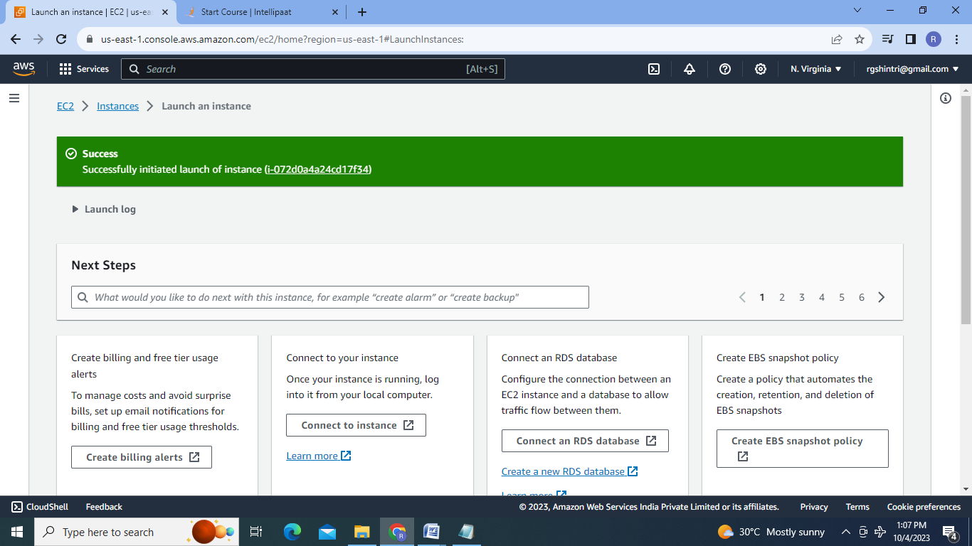

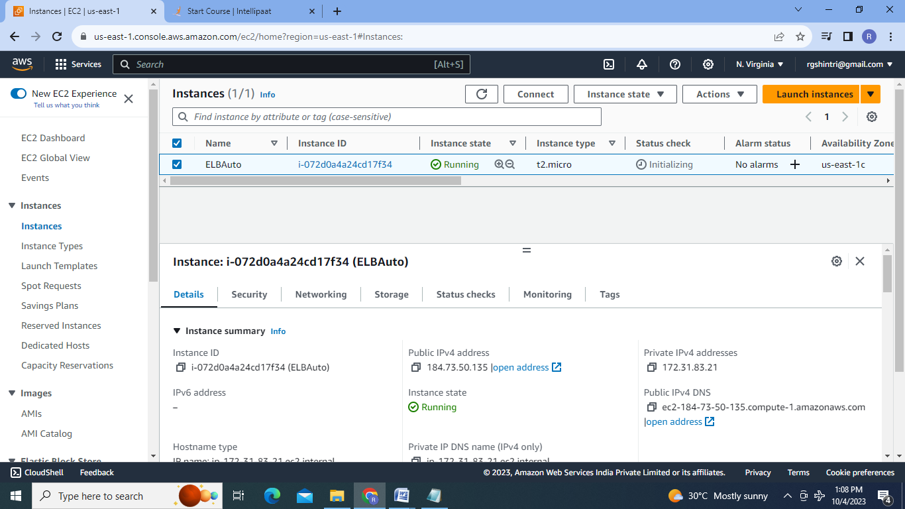

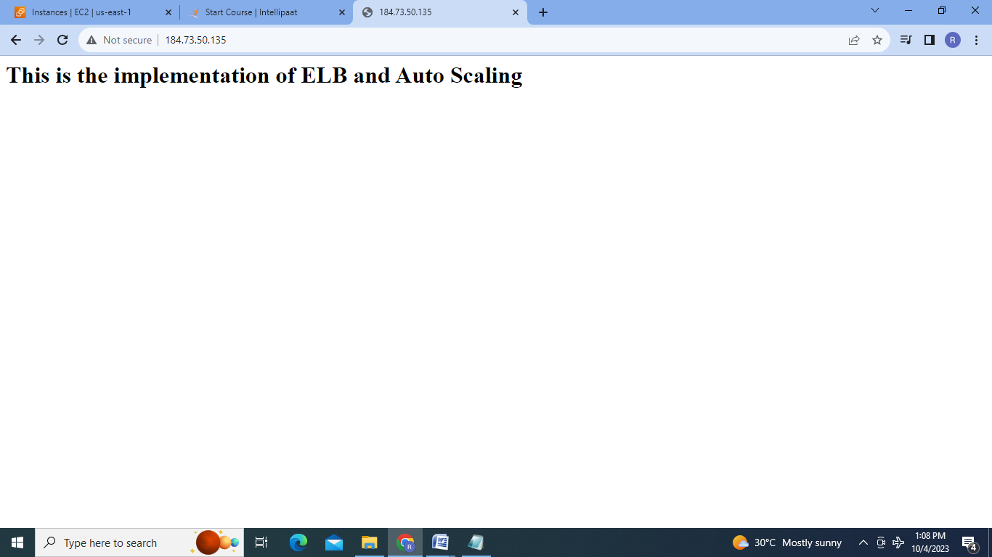

2.Create the AMI of EC2 instance:

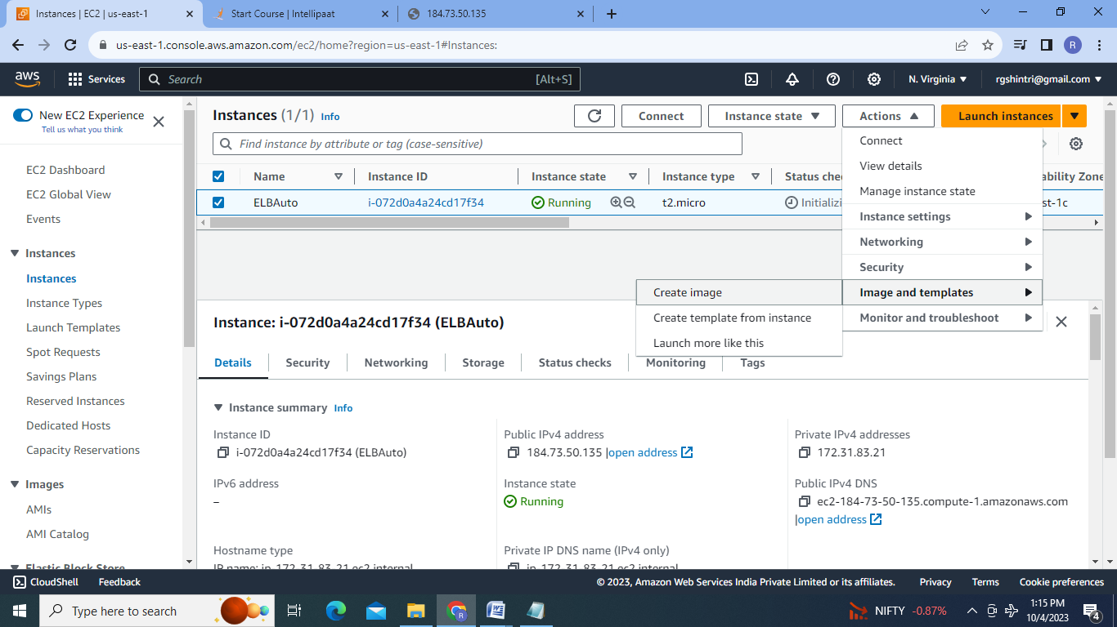

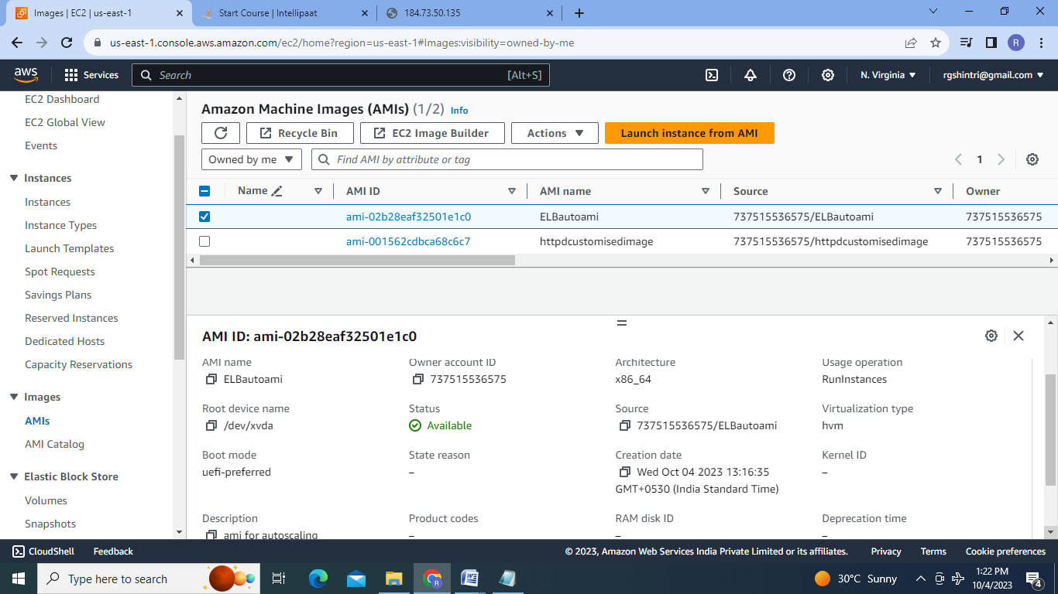

3.Create the Target group:

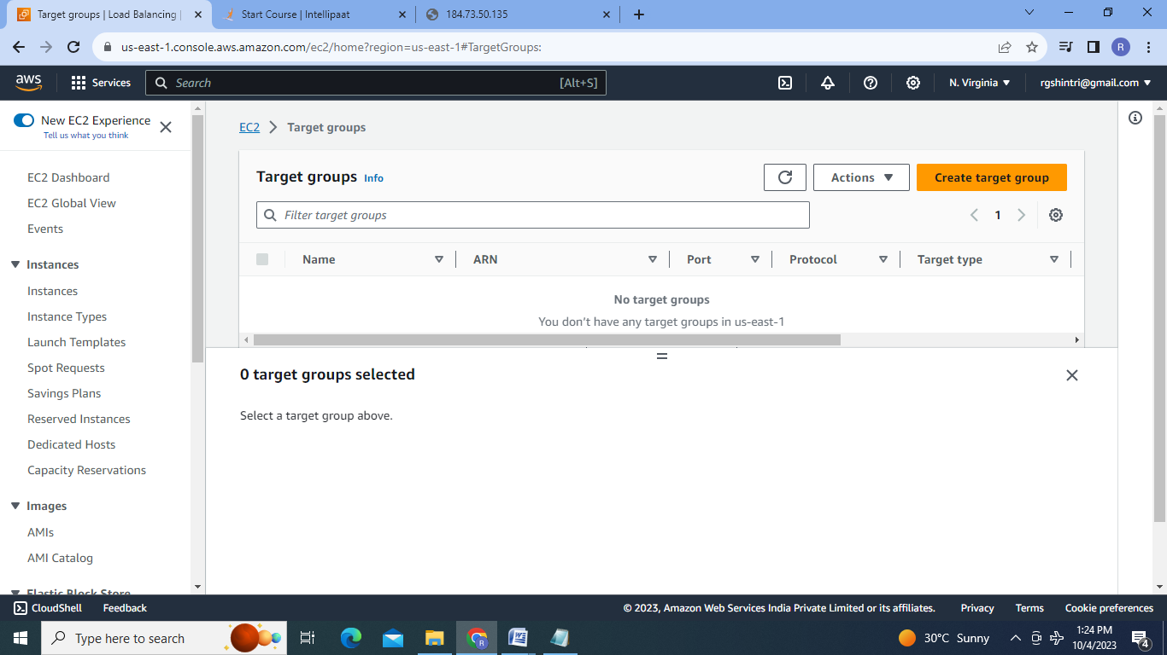

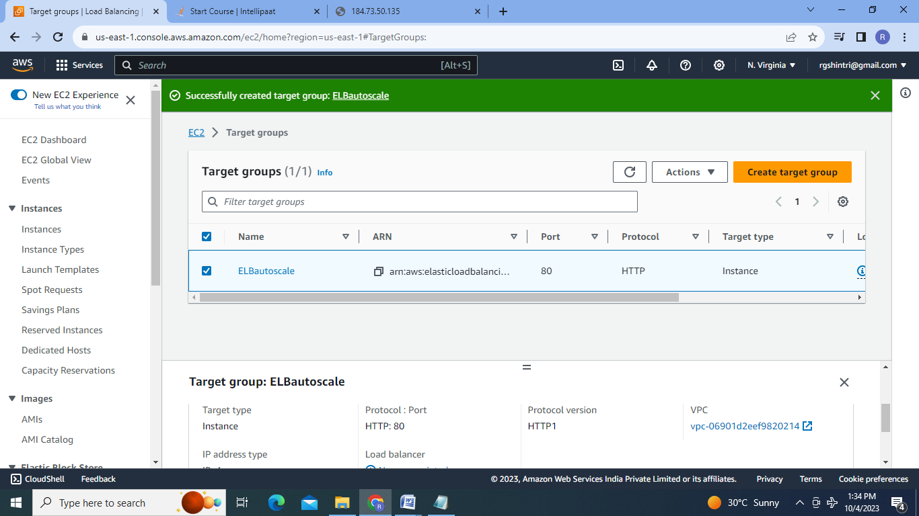

4.Create Load Balancer:

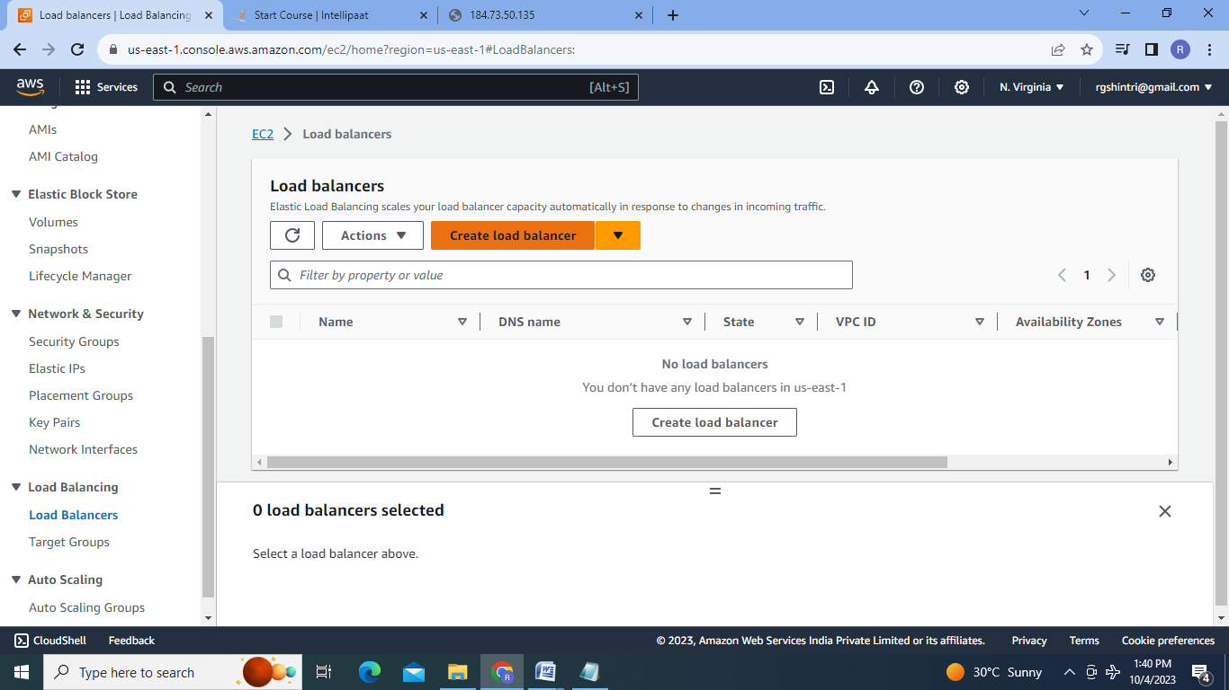

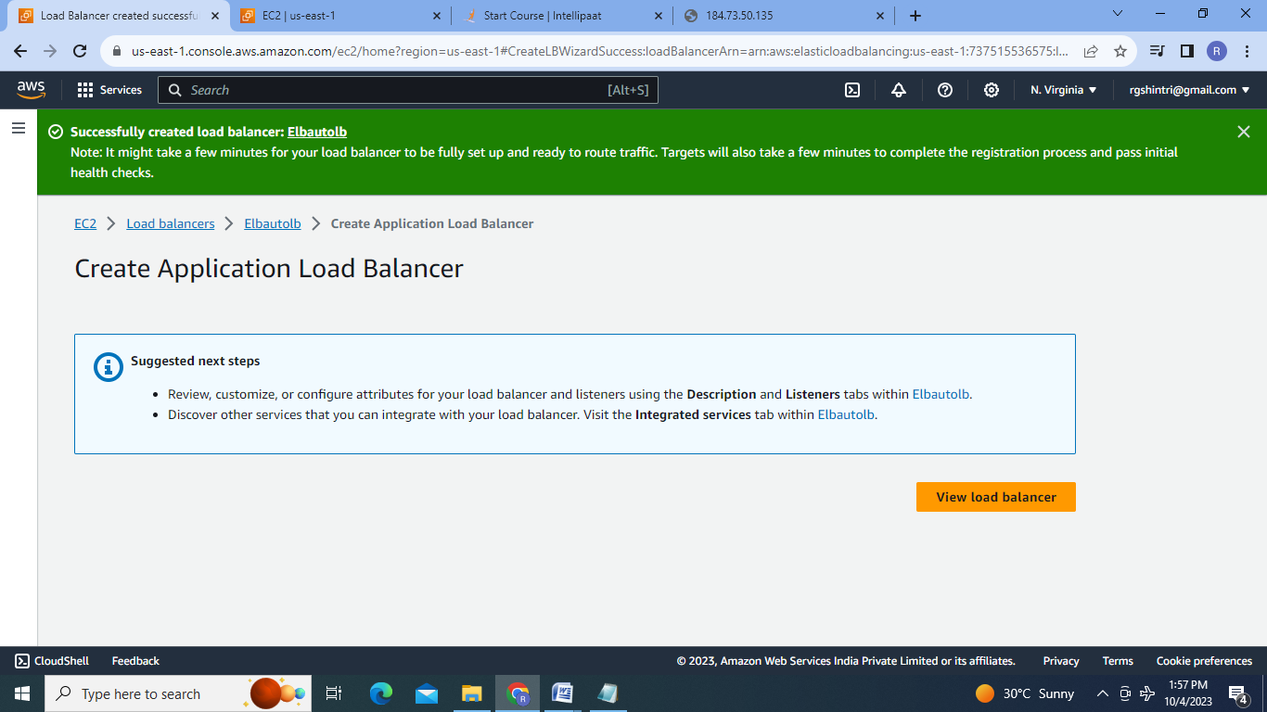

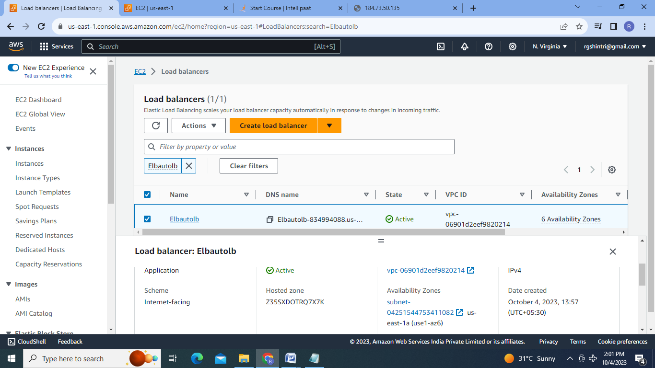

4.Create Launch Tempelate:

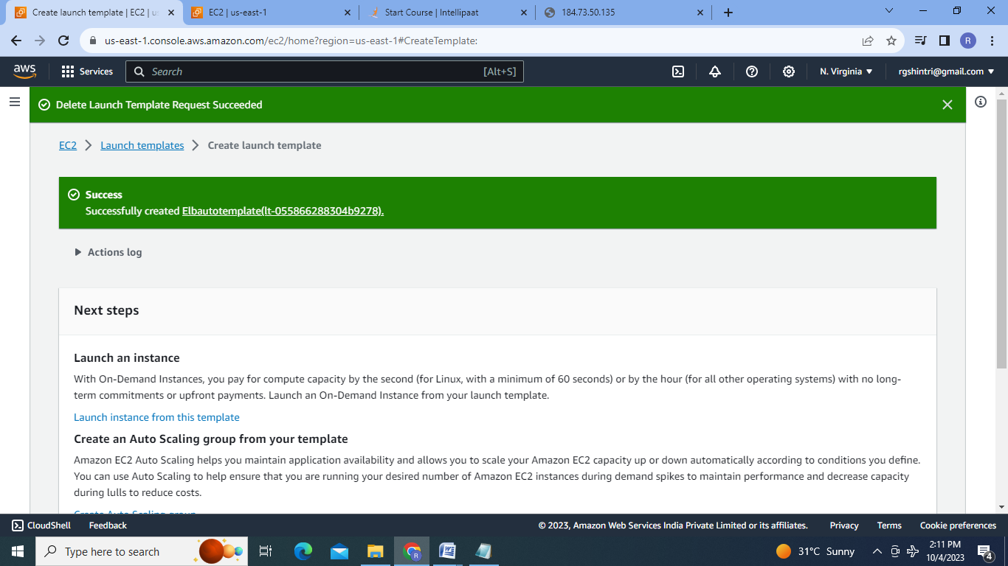

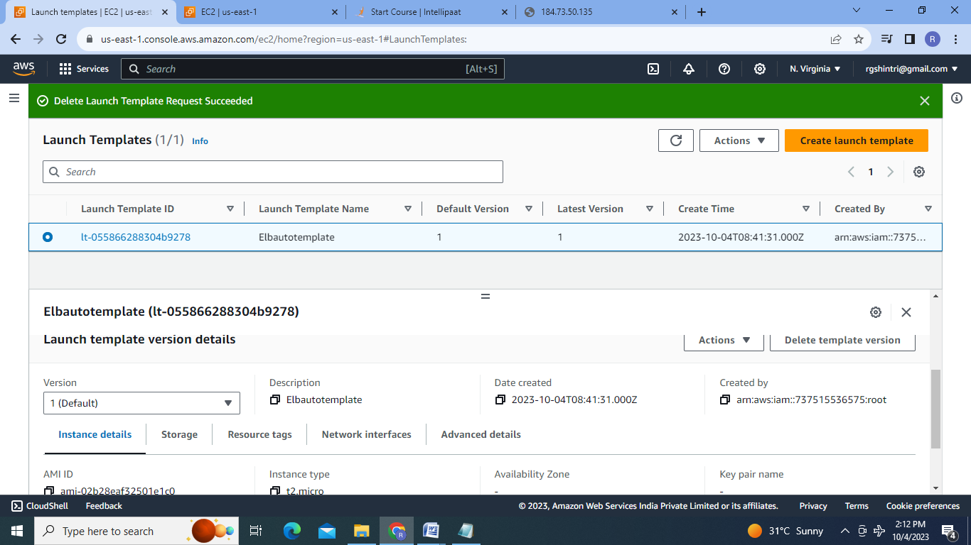

5.Create Autoscaling Group:

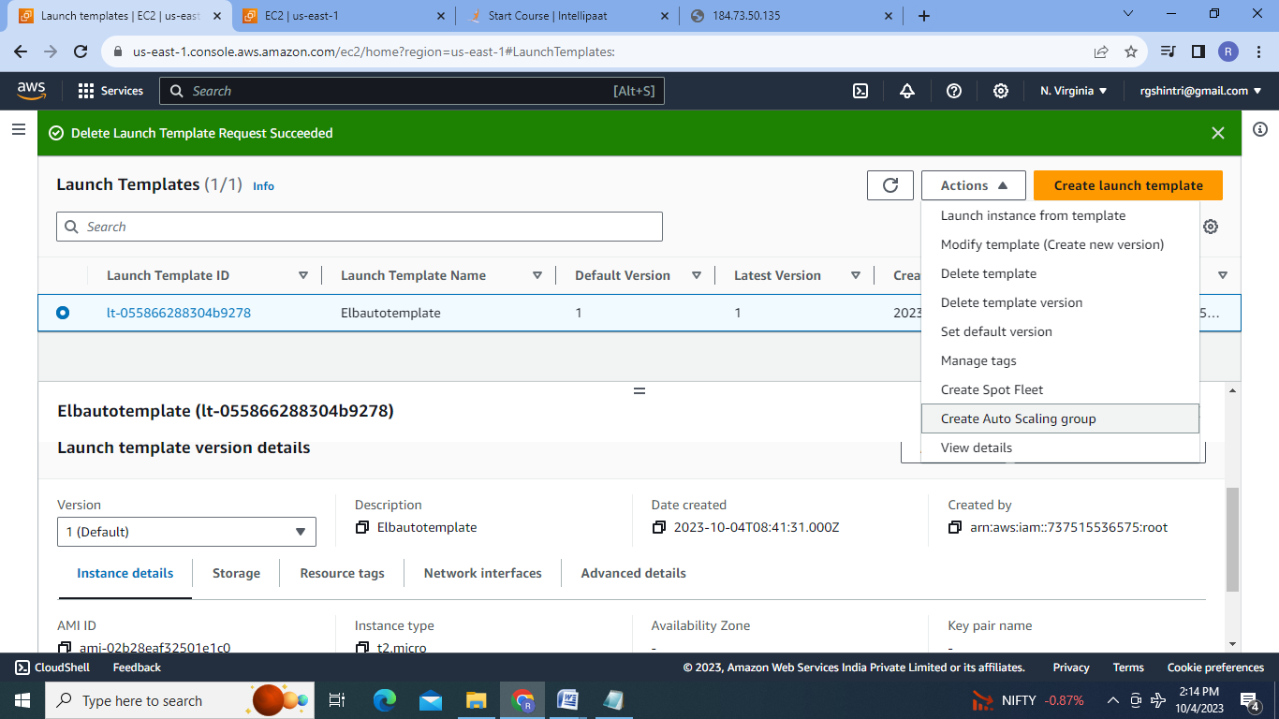

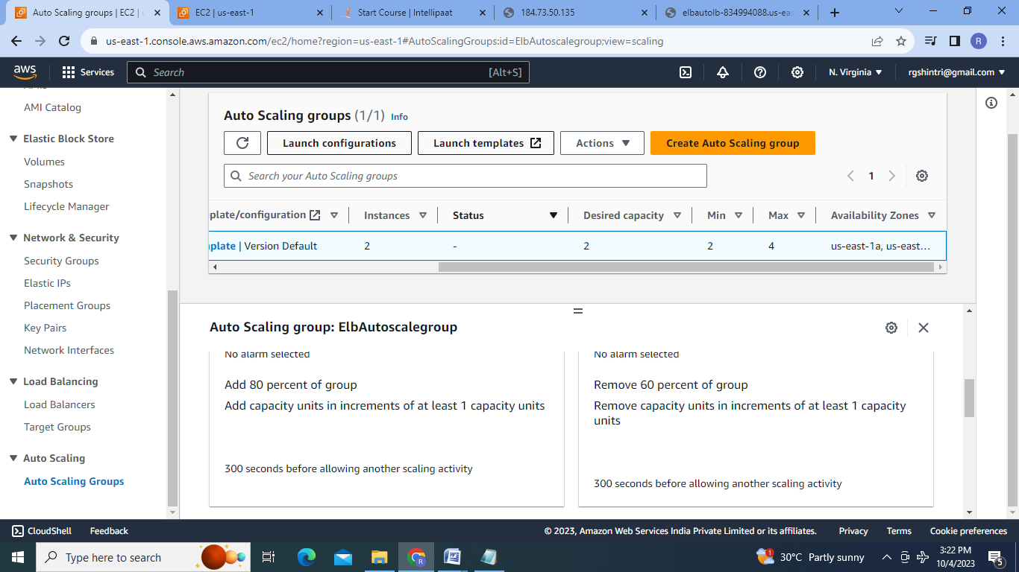

6.Test Autoscaling group:

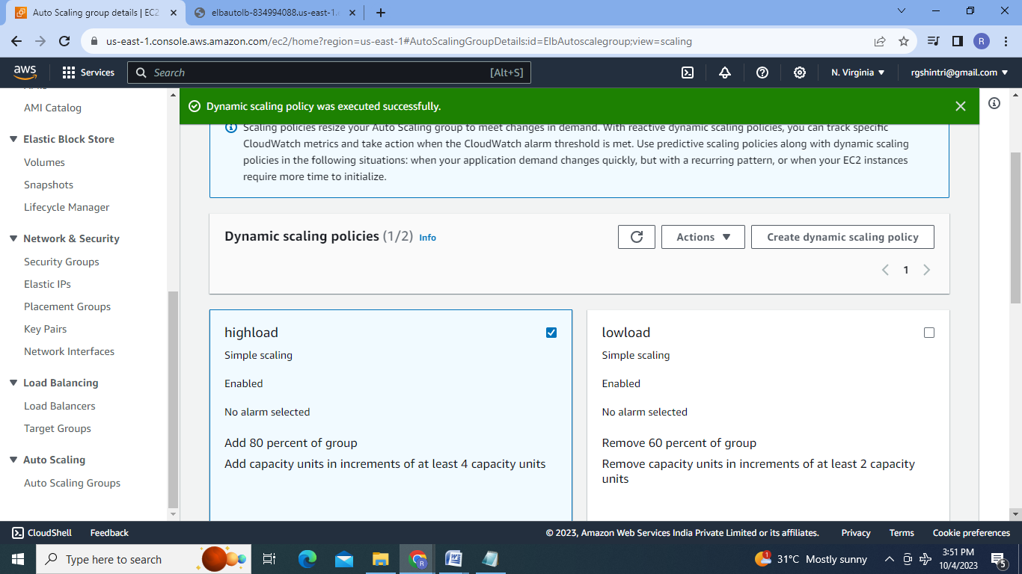

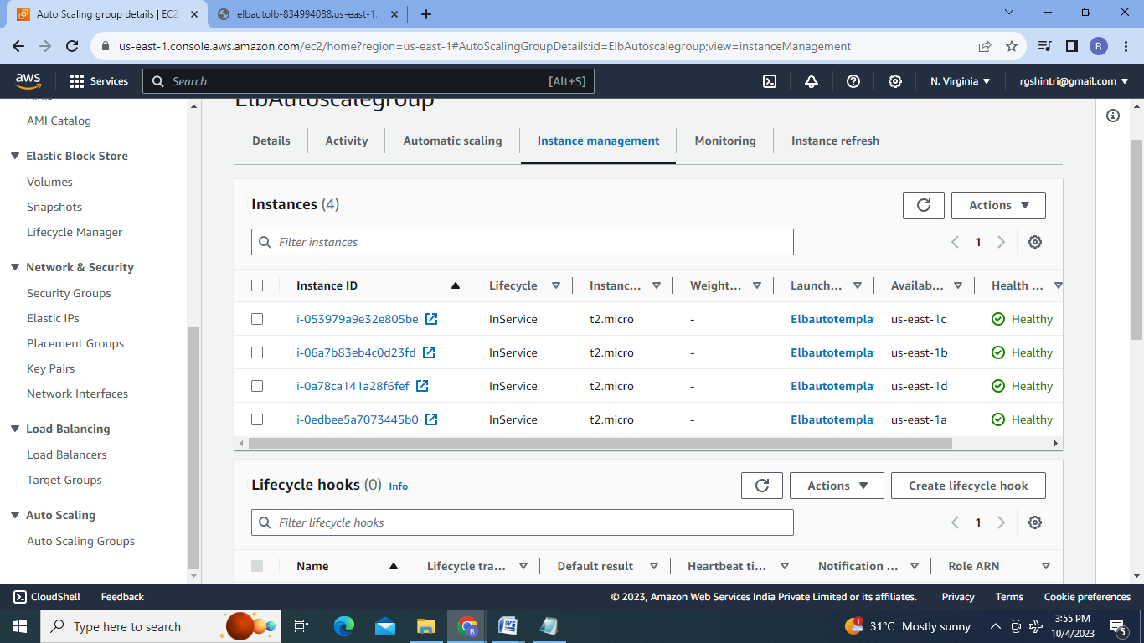

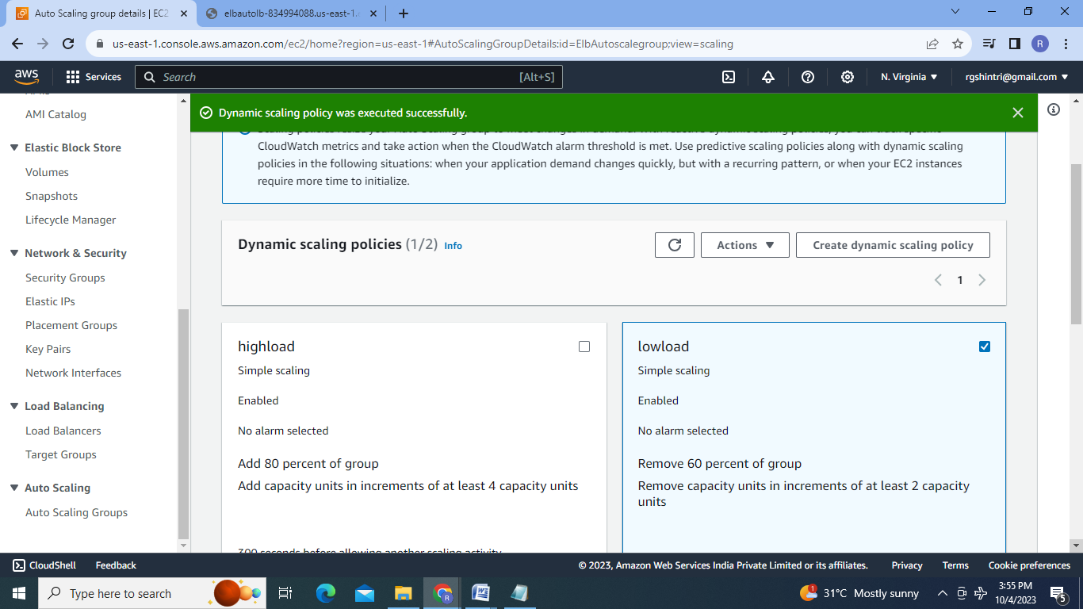

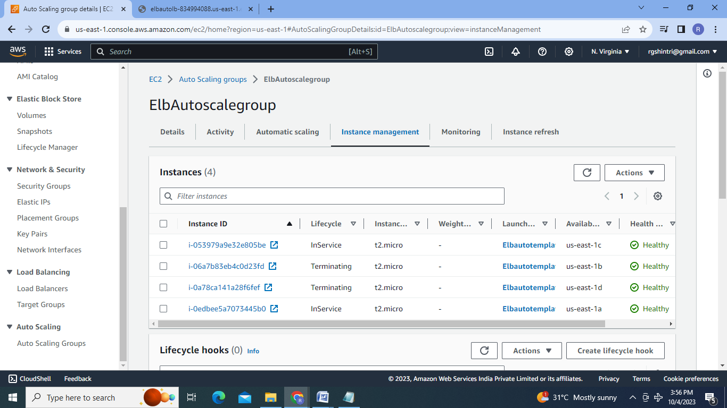

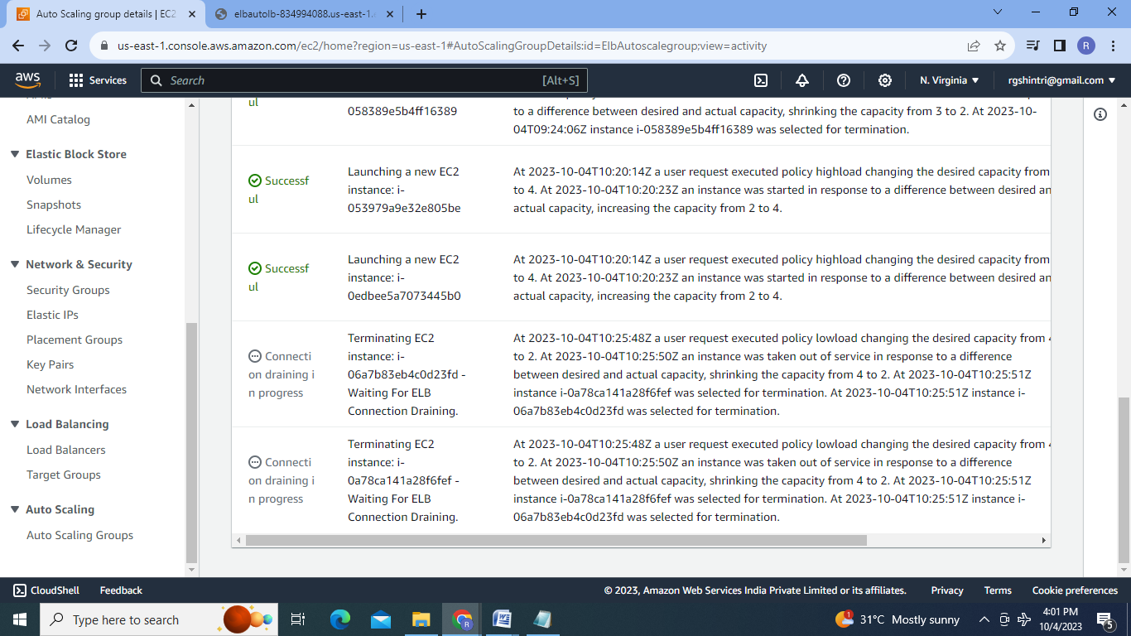

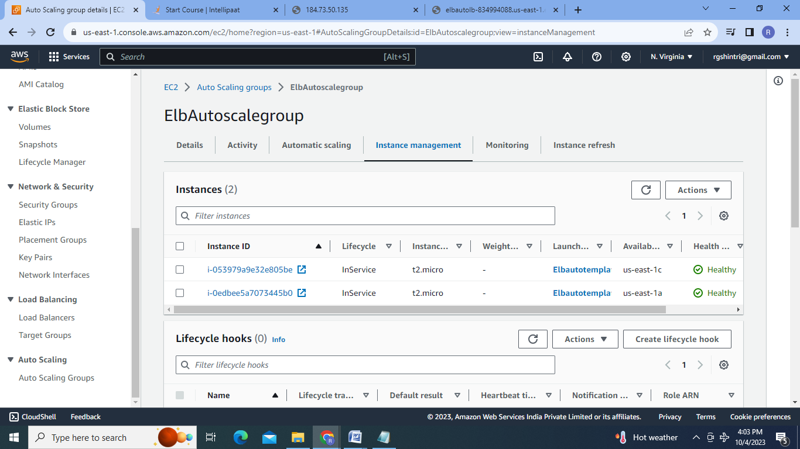

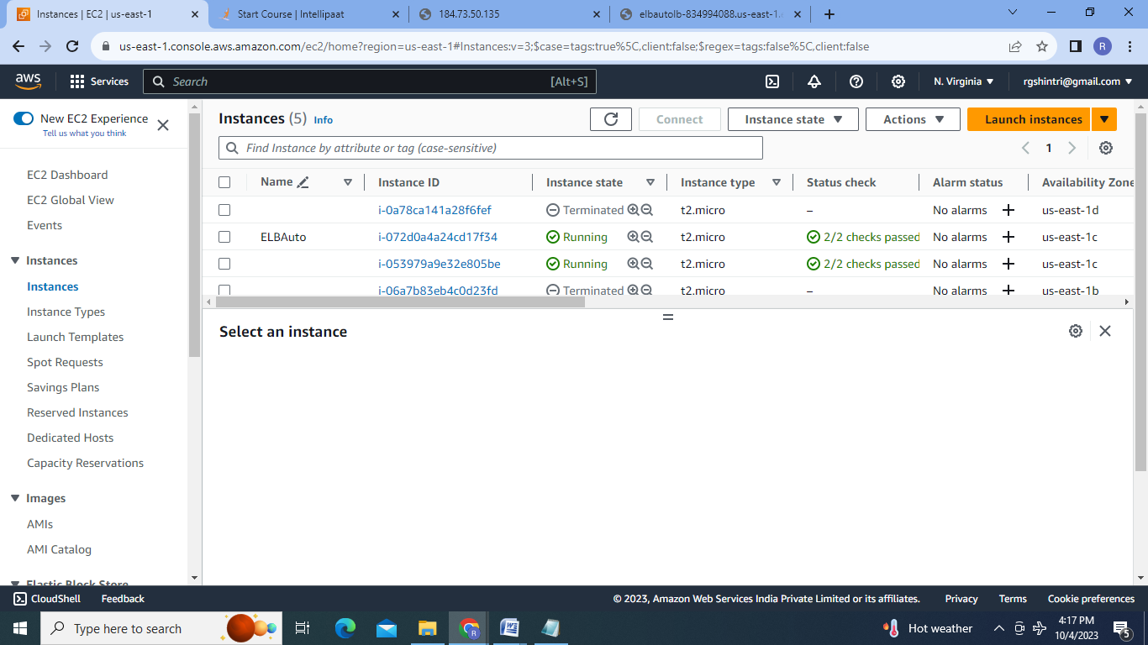

**Conclusion** :Autoscaling will either increase or decrease the no. of resources according to the traffic high time or low time.

**2. Create the load balancer to distribute the load between compute resources**.

Steps:

1.Create two EC2 instances showing 2 different web servers running :

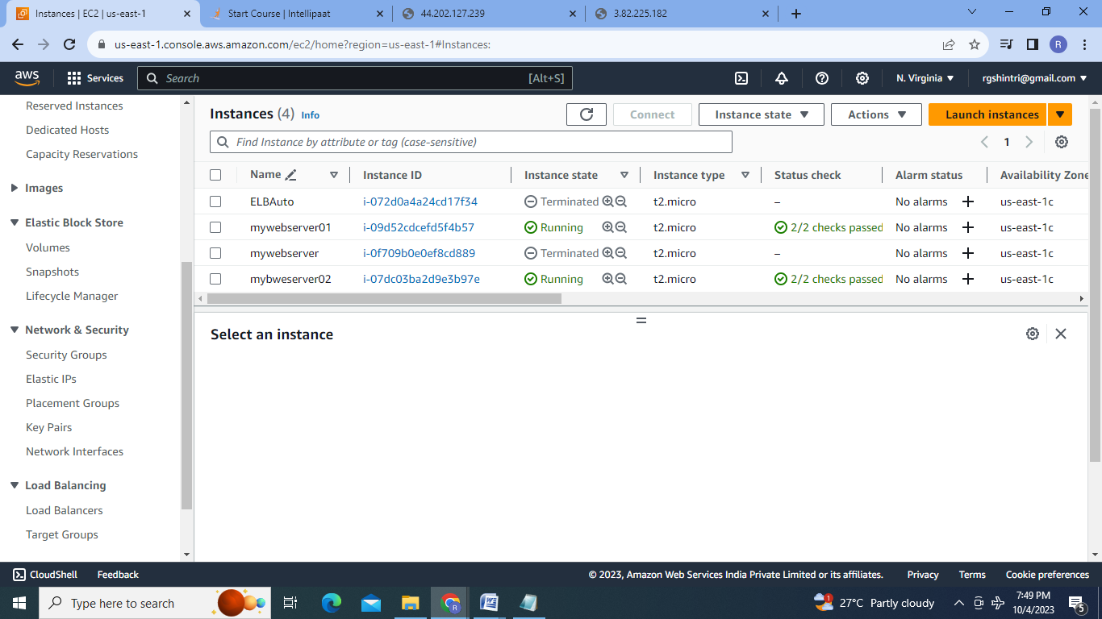

2.Create Target Group:

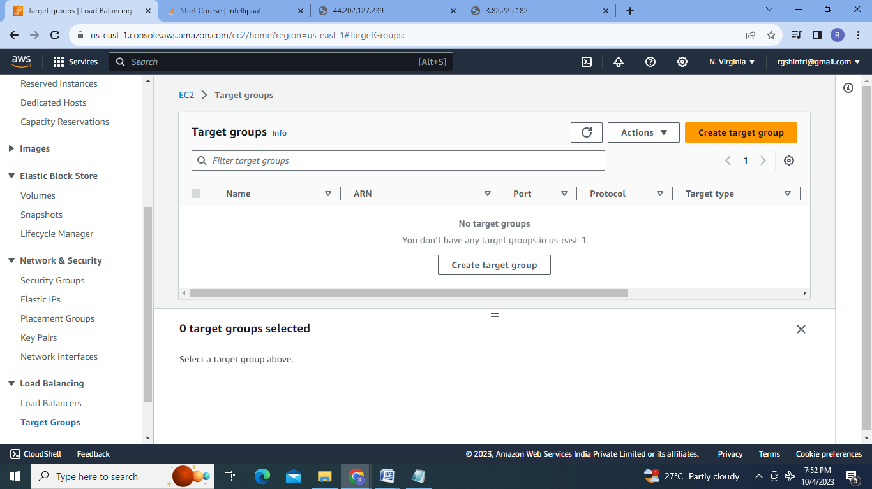

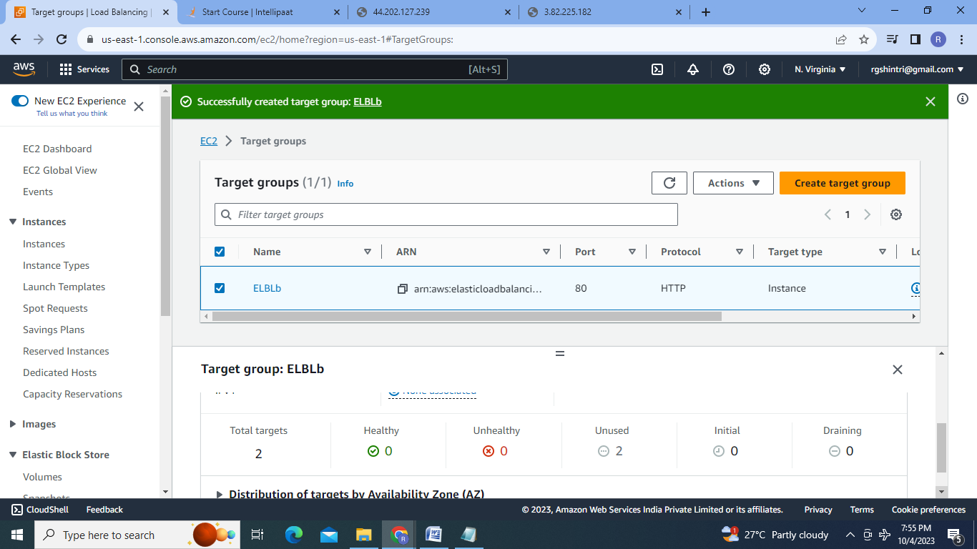

3.Create Load Balancer:

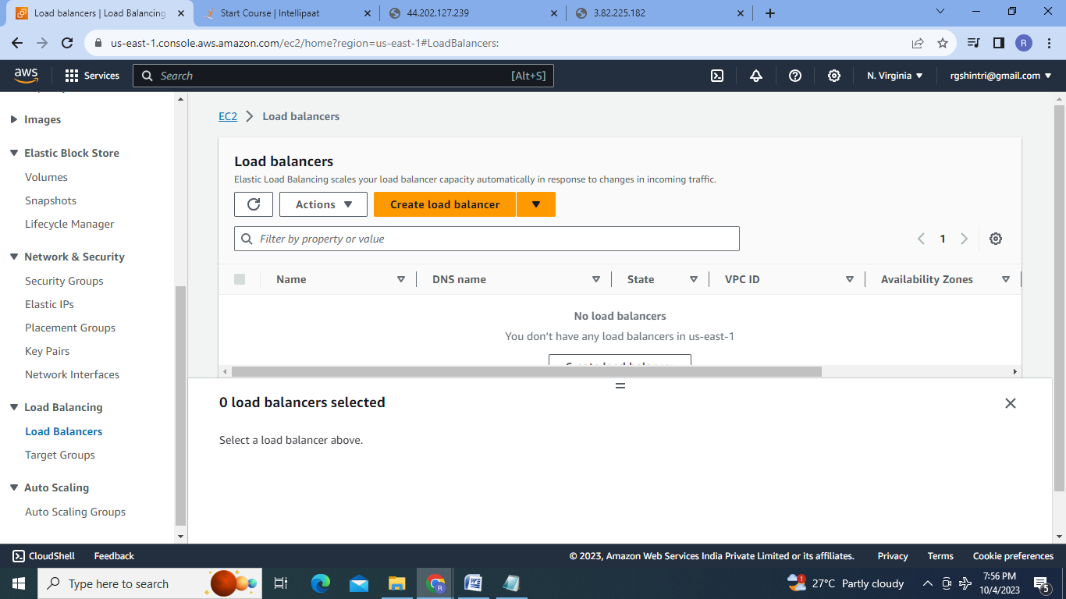

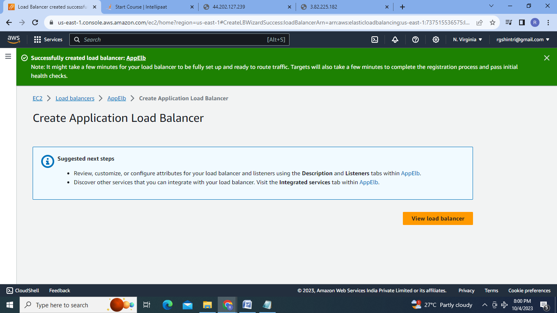

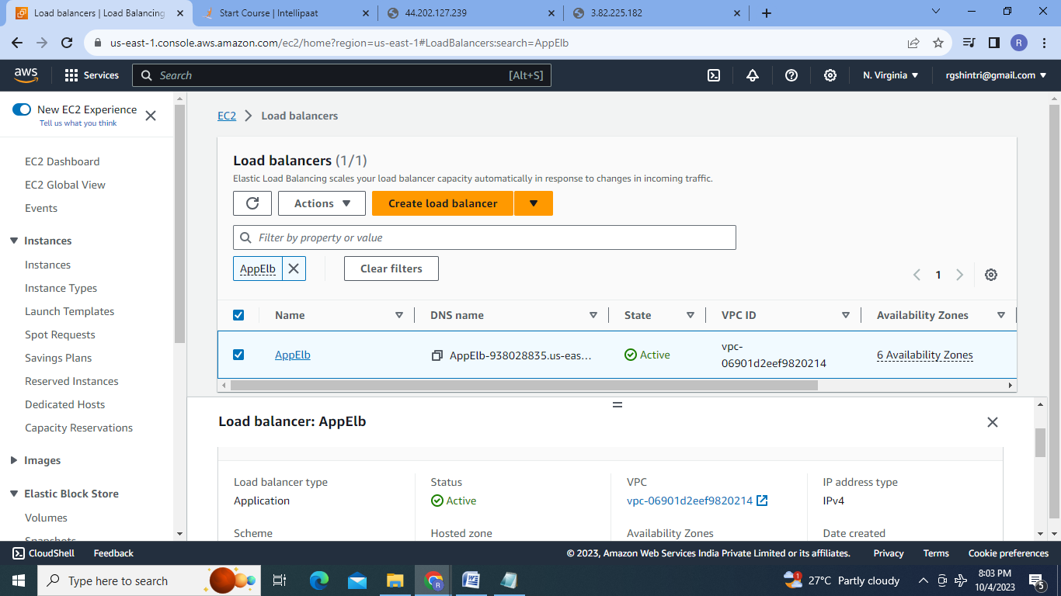

4.Test the Application load balancer by selecting DNS name And browsing it:

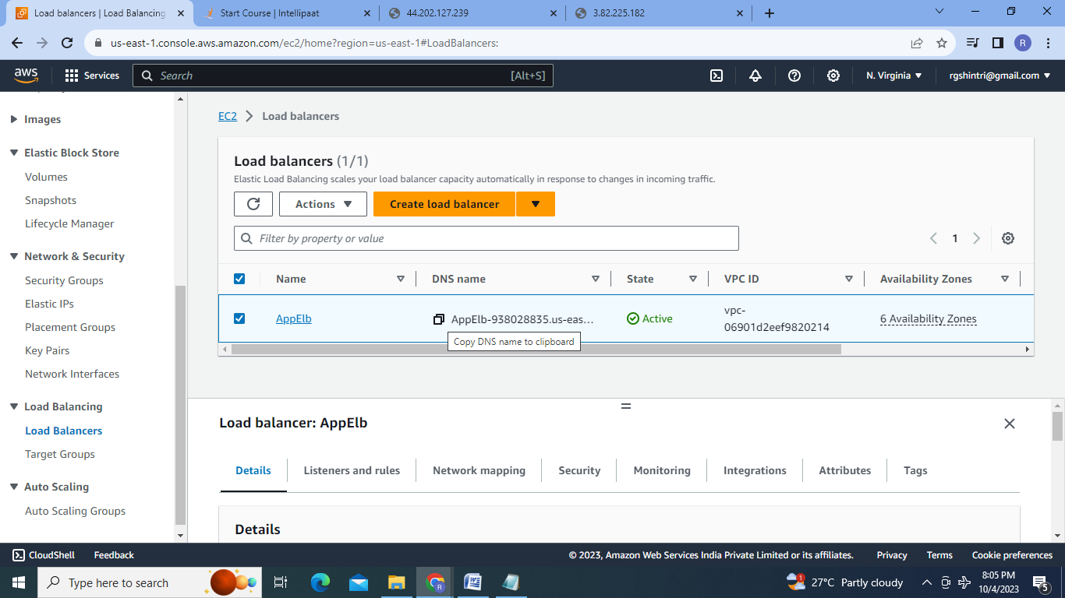

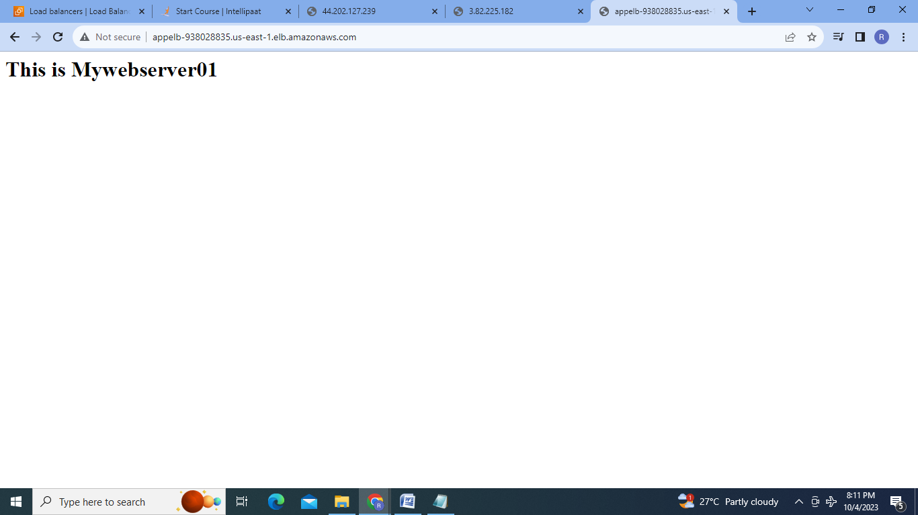

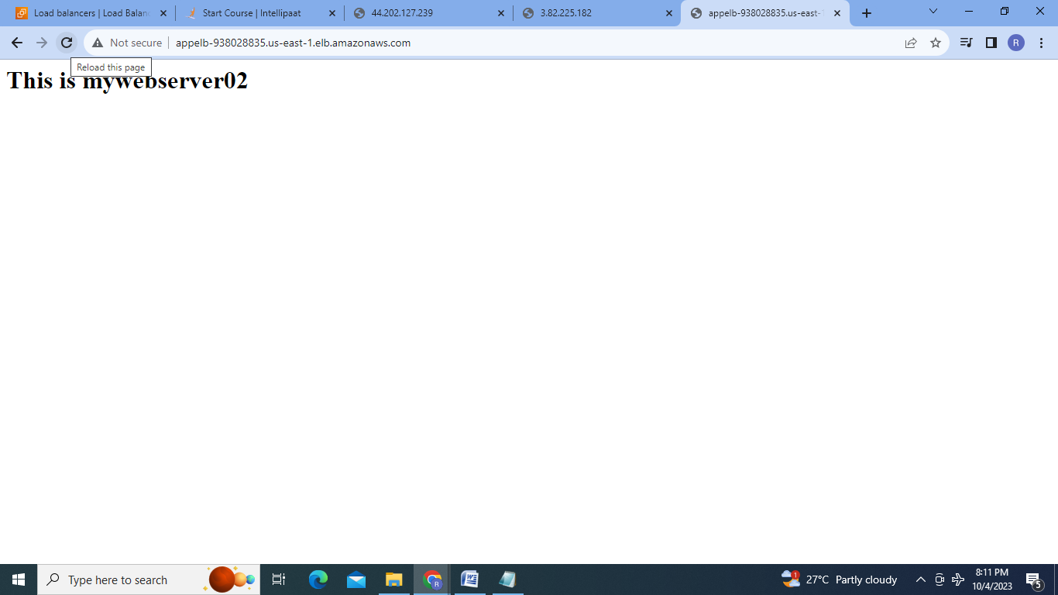  
**Conclusion** :So we can create the Load Balancer which works during the high time which distributes the traffic among the resources.

**3. Create the Route53 configuration:**

Steps: 1.Create EC2 instance on which a web server is running upon it .

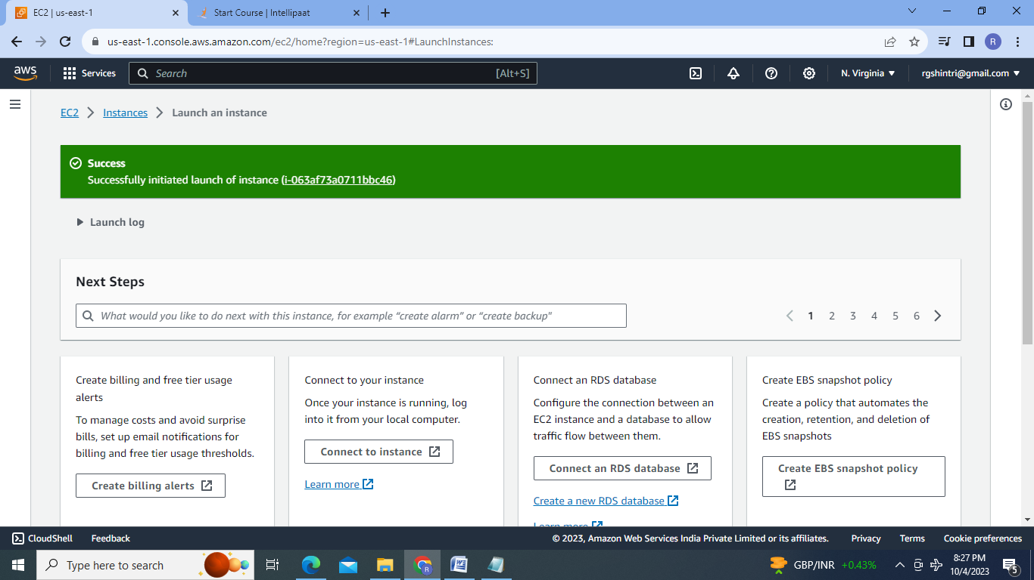

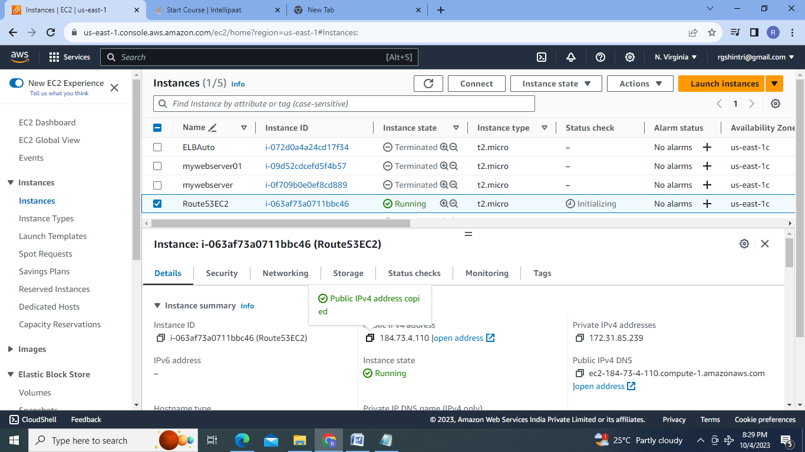

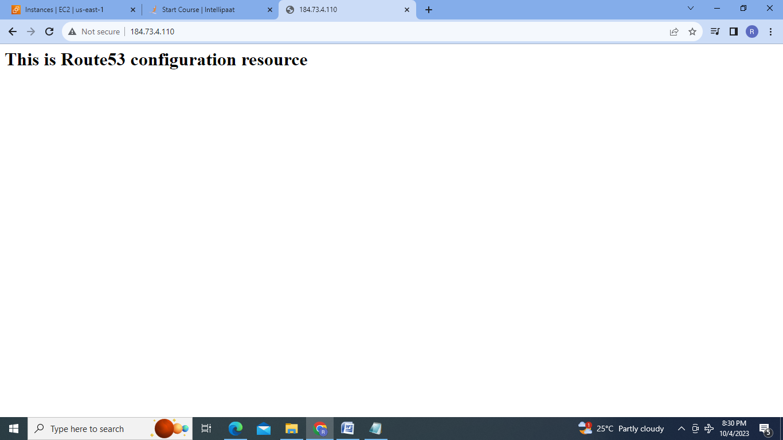

2.Create Route53 configuration by creating Hosted zones:

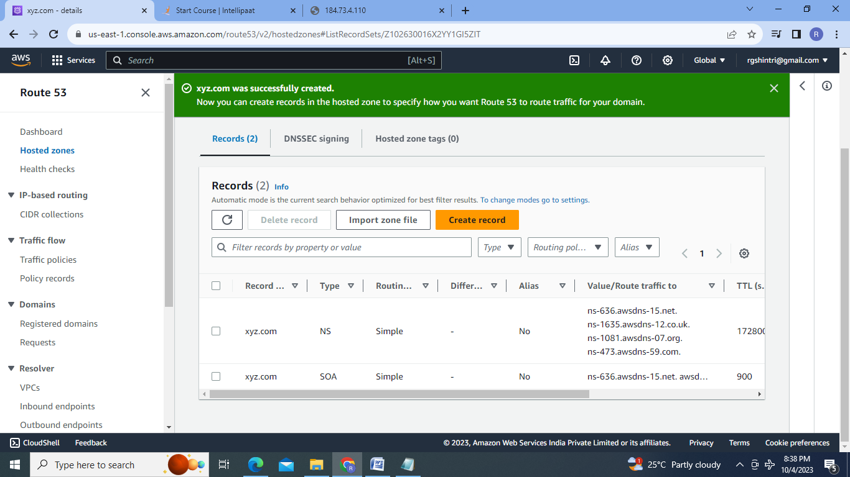

3.Create Records to Route the EC2 resource to xyz.com(company’s Domain):

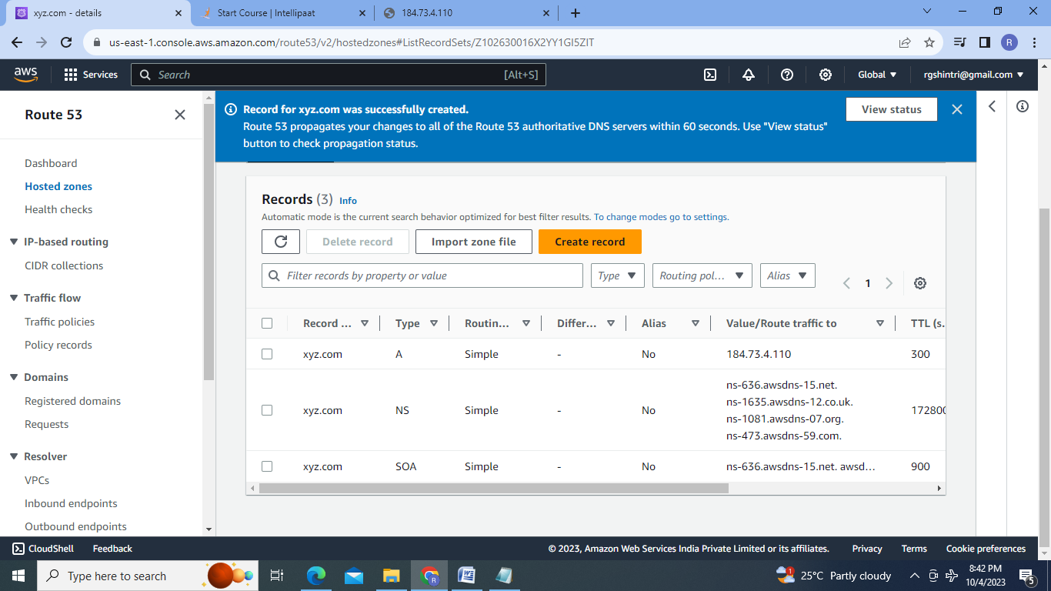

**Conclusion** : We can route the resources to Company’s Domain Name(xyz.com) by using Route53 AWS service.

